702-pumpcontrol102
Design Report
References:
- IMD111T datasheet
- iMOTION Software Reference Manual

- EVAL-M7-D111T user guide
  - Schematics
- EVAL-M7-LVMOS-INV user guide
  - Schematics
- REF_Fridge_D111T_RC2_SL user guide
  - Schematics
- iMOTION Link User Manual

- MOSFET Gate Drive Circuit application note
- Accurate Thermal Calculations on the Back of a Napkin

Shunt resistors
$$I_{pk}=10A, P_{res\left(max\right)}=1W$$
$$R_{tot}=\frac{0.15}{5}=0.03Ω=30mΩ$$
$$P_{tot\left(max\right)}=R_{tot}*I_{pk}^{2}=30m*{10}^{2}=3W$$
$$P_{res\left(pk\right)}=\frac{P_{tot}}{5}=0.6W$$

$$P_{tot\left(RMS\right)}=R_{tot}*I_{RMS}^{2}=30m*{4.2}^{2}=0.5W$$
$$P_{res\left(RMS\right)}=\frac{0.5}{5}=0.1W$$

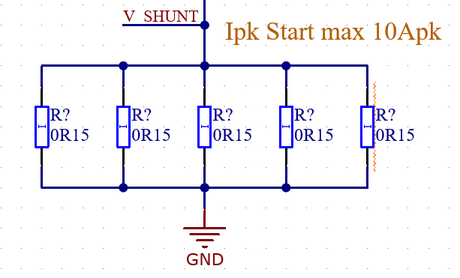

Bus sense
$$V_{ADC\left(max\right)}=3.3V$$
$$V_{DC\left(max\right)}=\frac{100k+1000k}{100k}*3.3V=36.3V$$
$$τ_{RC}=1Meg*10n=10μs$$
$$f_{c}=\frac{1}{2πRC}=\frac{1}{2π*1Meg*10n}=16Hz$$

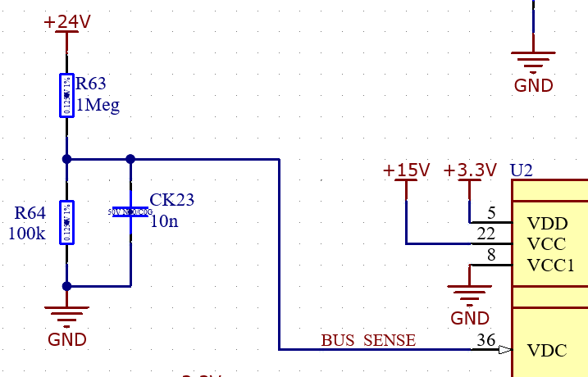
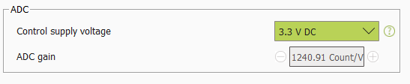
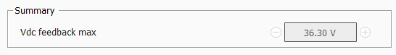

Current measurement
$$G_{int}=3, R_{shunt}=30mΩ$$
$$V_{offset}=\frac{2k}{2k+10k}*3.3V=0.55V=550mV$$
$$V_{shunt\left(min\right)}=-V_{offset}=-550mV$$
$$V_{shunt\left(max\right)}=\frac{V_{ADC}}{G_{int}}-V_{offset}=\frac{3.3}{3}-0.55=550mV$$
$$G_{ext}=\frac{10k}{2k+10k}=0.833$$
$$Current gain=G_{ext}*R_{shunt}=0.833*30mΩ=25mV/A$$
$$I_{\left(min\right)}=\frac{V_{shunt\left(min\right)}}{Current gain}=\frac{-550mV}{25}=-22A$$
$$I_{\left(max\right)}=\frac{V_{shunt\left(max\right)}}{Current gain}=\frac{550mV}{25}=22A$$
$$P_{res\left(max\right)}=\frac{U^{2}}{R}=5.45mW$$
$$τ_{RC}=2k*220p=440ns=0.44μs$$
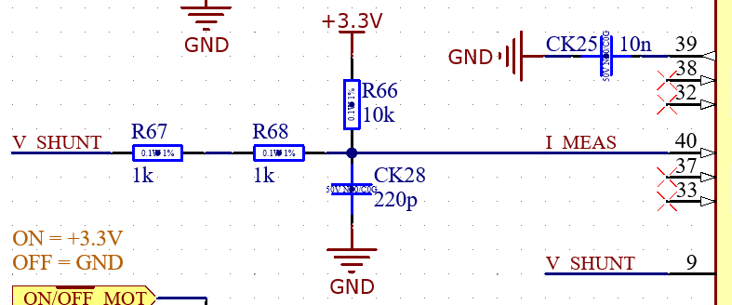
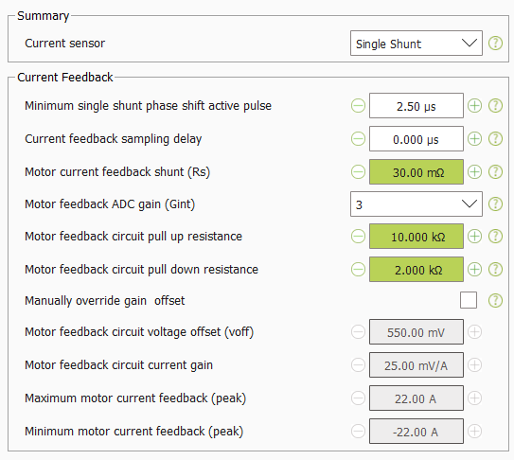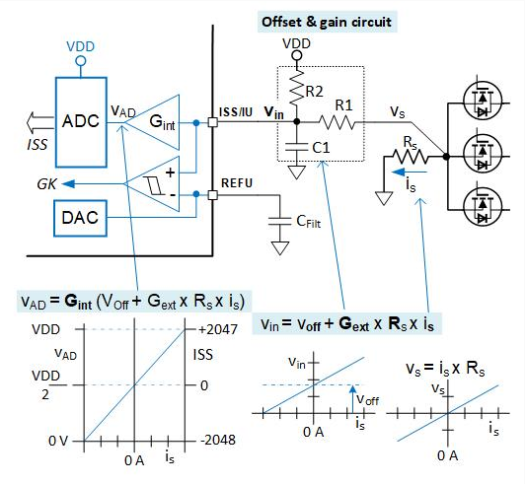

Parameter selection
Multiple parameter sets not used, so PARAM pin can be left floating. Parameter set chosen during firmware flash.
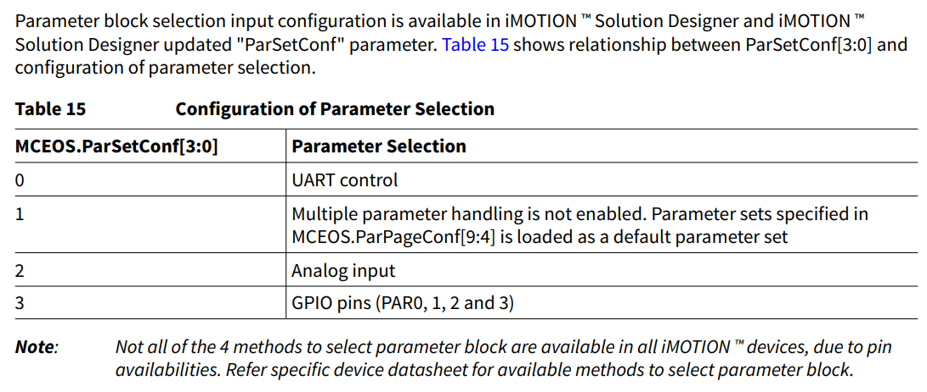
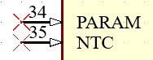

Motor direction
DIR pin should be LOW so motor direction is positive.
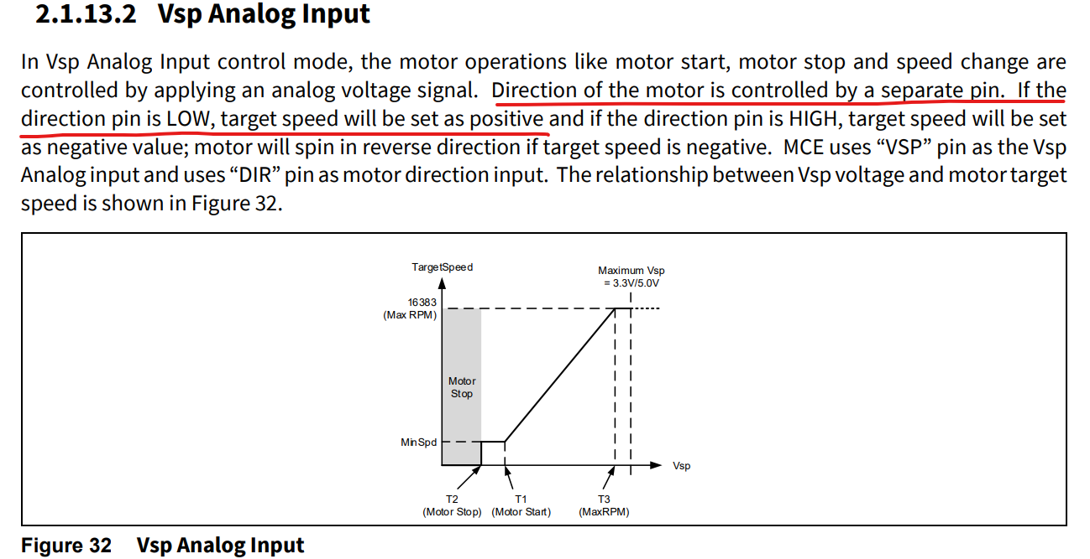
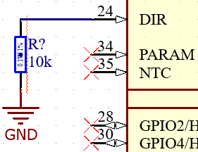

Motor speed
$$S_{typ}=1700 RPM, S_{min}=200 RPM, S_{max}=2000 RPM$$
$$V_{target}=\frac{\left(S_{typ}-S_{min}\right)}{\left(S_{max}-S_{min}\right)}*\left(V_{max}-V_{min}\right)+V_{min}$$
$$V_{target}=\frac{\left(1700-200\right)}{\left(2000-200\right)}*\left(3.16-0.79\right)+0.79=2.77V$$
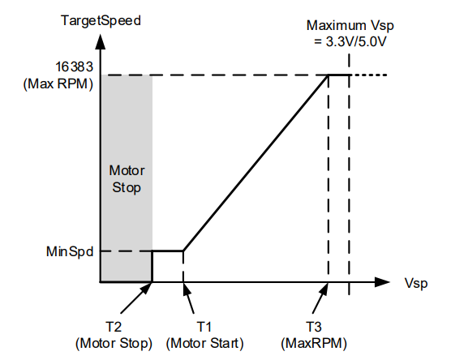
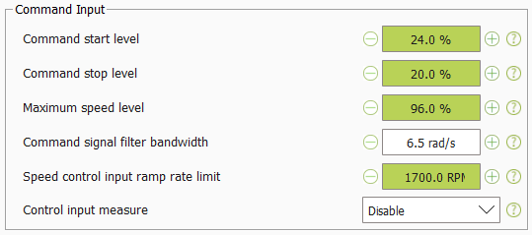
$$R_{ds\left(on\right)}≤2Ω$$
$$VSP=\frac{10k+6.8k}{10k+6.8k+2.2k+1k+R_{ds\left(on\right)}}*3.3V≈2.77V$$
$$I_{div}=\frac{3.3V}{1k+2.2k+6.8k+10k+R_{ds\left(on\right)}}=165μA$$
$$τ_{RC}=(1k+2.2k)*100n=320μs$$
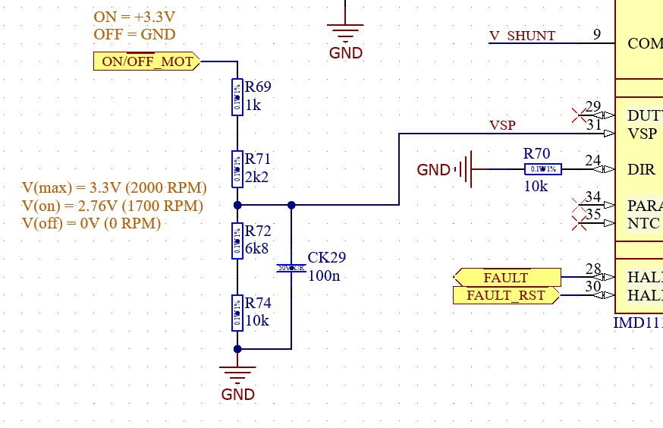

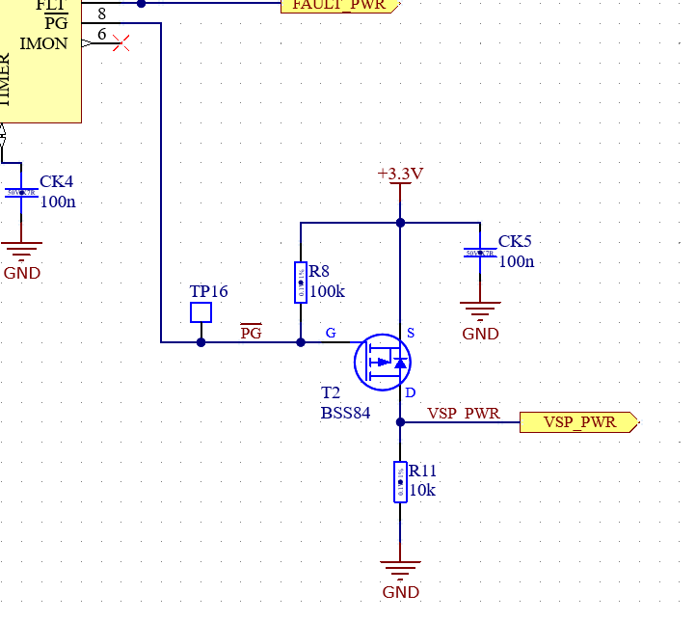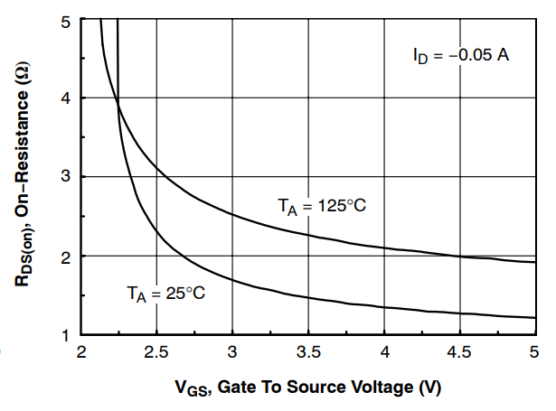

+15V and +3.3V power supplies
$$Q_{g\left(max\right)}=63nC, f_{sw\left(max\right)}=40kHz, N=6 transistors$$
$$I_{G\left(max\right)}=Q_{g\left(max\right)}*f_{sw\left(max\right)}=63n*40k=2.52mA$$
$$I_{CC\left(max\right)}=N*I_{g\left(max\right)}=6*2.52m=15.12mA$$

$$I_{QCC\left(nom\right)}=0.75mA$$
$$I_{+15V\left(nom\right)}=I_{QCC\left(nom\right)}+I_{CC\left(nom\right)}$$
$$I_{+15V\left(nom\right)}≈10mA$$
$$I_{QCC\left(max\right)}=1.5mA$$
$$I_{+15V\left(max\right)}=I_{QCC\left(max\right)}+I_{CC\left(max\right)}=1.5m+15.12m$$
$$I_{+15V\left(max\right)}=16.62mA$$

$$I_{DD\left(nom\right)}=12mA$$
$$I_{+3.3V\left(nom\right)}=15mA$$
$$I_{DD\left(max\right)}=20mA$$
$$I_{+3.3V\left(max\right)}=25mA$$

IC (IMD111T):
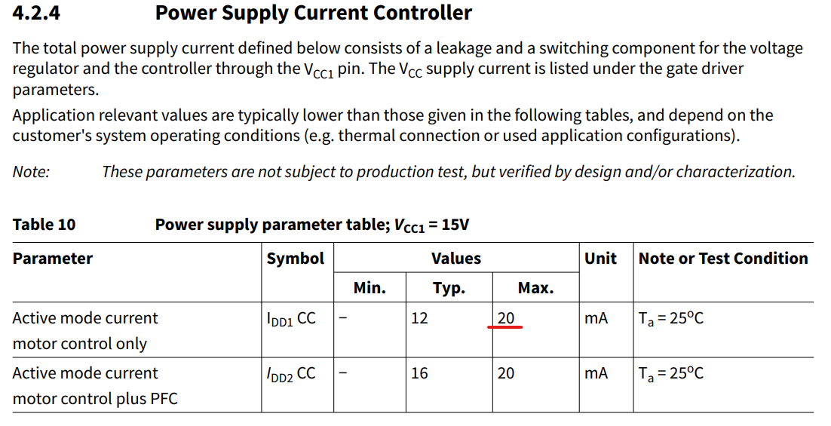

Transistors (PSMN2R6-40YS):
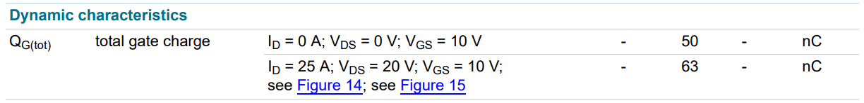
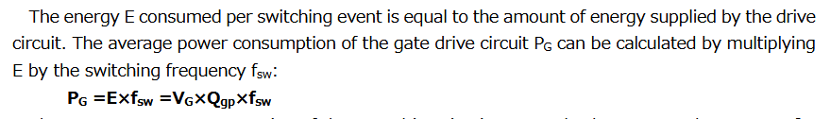

Regulator:
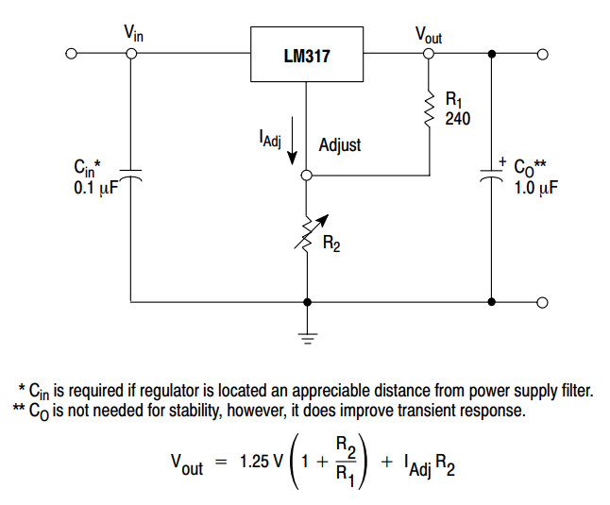

Overall power loss and self-heating
$$T_{amb}=40°C$$
- +15V regulator (LM317):
$$P_{+15V_reg\left(nom\right)}=0.44W$$
$$T_{+15V_reg\left(nom\right)}=62.12°C$$
- +3.3V regulator (LM317):
$$P_{+3.3V_reg\left(nom\right)}=0.32W$$
$$T_{+3.3V_reg\left(nom\right)}=55.99°C$$
- Shunt resistors (5x):
$$P_{R\left(nom\right)}=0.104W$$
$$T_{R\left(nom\right)\left(polygon\right)}=48.41°C$$
- Inverter transistors (6x):
$$P_{T_{inv}\left(nom\right)}=0.035W$$
$$T_{T_{inv}\left(nom\right)\left(polygon\right)}=42.82°C$$
- +24V power transistor:
$$P_{T_{+24V}\left(nom\right)}=0.035W$$
$$T_{T_{+24V}\left(nom\right)\left(polygon\right)}=43.16°C$$
- +24V power shunt resistor:
$$P_{R_{+24V}\left(nom\right)}=0.087W$$
$$T_{T_{+24V}\left(nom\right)\left(polygon\right)}=52.75°C$$
$$P_{tot\left(nom\right)}=P_{+15V_reg\left(nom\right)}+P_{+3.3V_reg\left(nom\right)}+5P_{R\left(nom\right)}+6P_{T_{inv}\left(nom\right)}+P_{T_{+24V}\left(nom\right)}+P_{R_{+24V}\left(nom\right)}$$
$$P_{tot\left(nom\right)}=0.44+0.32+5*0.104+6*0.035+0.035+0.087$$
$$P_{tot\left(nom\right)}=1.614 W$$

Phase output snubber calibration
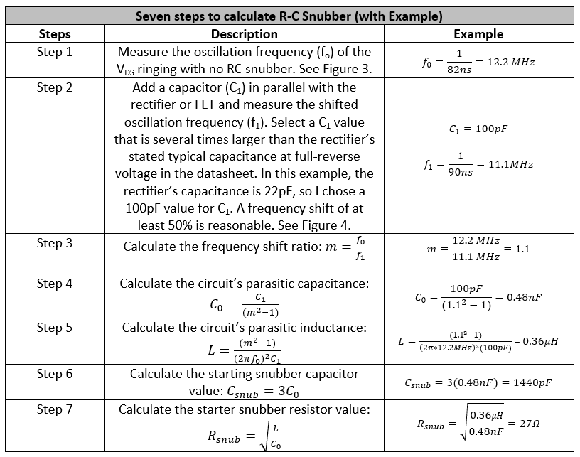

$$U phase:$$

$$Top:$$
$$f_{0}=22.8 MHz$$
$$Choose C_{1}=2.2 nF$$
$$f_{1}=12.5 MHz$$
$$m=\frac{f_{0}}{f_{1}}=1.824$$
$$C_{0}=\frac{C_{1}}{\left(m^{2}-1\right)}=0.945 nF$$
$$L=\frac{\left(m^{2}-1\right)}{{\left(2πf_{0}\right)}^{2}C_{1}}=51.54 nH$$
$$C_{snub}=3C_{0}=2.835 nF$$
$$Choose C_{snub}=4.7 nF$$
$$R_{snub}=\sqrt{\frac{L}{C_{0}}}=7.385 Ω$$
$$Choose R_{snub}=5 Ω$$
$$Bot:$$
$$f_{0}=24 MHz$$
$$Choose C_{1}=2.2 nF$$
$$f_{1}=11.5 MHz$$
$$m=\frac{f_{0}}{f_{1}}=2.087$$
$$C_{0}=\frac{C_{1}}{\left(m^{2}-1\right)}=0.656 nF$$
$$L=\frac{\left(m^{2}-1\right)}{{\left(2πf_{0}\right)}^{2}C_{1}}=67.08 nH$$
$$C_{snub}=3C_{0}=1.968 nF$$
$$Choose C_{snub}=4.7 nF$$
$$R_{snub}=\sqrt{\frac{L}{C_{0}}}=10.11 Ω$$
$$Choose R_{snub}=5 Ω$$

$$V phase:$$

$$Top:$$
$$f_{0}=22.5 MHz$$
$$Choose C_{1}=2.2 nF$$
$$f_{1}=11.5 MHz$$
$$m=\frac{f_{0}}{f_{1}}=1.957$$
$$C_{0}=\frac{C_{1}}{\left(m^{2}-1\right)}=0.777 nF$$
$$L=\frac{\left(m^{2}-1\right)}{{\left(2πf_{0}\right)}^{2}C_{1}}=64.36 nH$$
$$C_{snub}=3C_{0}=2.331 nF$$
$$Choose C_{snub}=4.7 nF$$
$$R_{snub}=\sqrt{\frac{L}{C_{0}}}=9.101 Ω$$
$$Choose R_{snub}=5 Ω$$
$$Bot:$$
$$f_{0}=23.8 MHz$$
$$Choose C_{1}=2.2nF$$
$$f_{1}=11.6 MHz$$
$$m=\frac{f_{0}}{f_{1}}=2.052$$
$$C_{0}=\frac{C_{1}}{\left(m^{2}-1\right)}=0.685 nF$$
$$L=\frac{\left(m^{2}-1\right)}{{\left(2πf_{0}\right)}^{2}C_{1}}=65.26 nH$$
$$C_{snub}=3C_{0}=2.055$$
$$Choose C_{snub}=4.7 nF$$
$$R_{snub}=\sqrt{\frac{L}{C_{0}}}=9.761 Ω$$
$$Choose R_{snub}=5 Ω$$

$$W phase:$$

$$Top:$$
$$f_{0}=24 MHz$$
$$Choose C_{1}=2.2 nF$$
$$f_{1}=11.7 MHz$$
$$m=\frac{f_{0}}{f_{1}}=2.051$$
$$C_{0}=\frac{C_{1}}{\left(m^{2}-1\right)}=0.686 nF$$
$$L=\frac{\left(m^{2}-1\right)}{{\left(2πf_{0}\right)}^{2}C_{1}}=64.10 nH$$
$$C_{snub}=3C_{0}=2.058 nF$$
$$Choose C_{snub}=4.7 nF$$
$$R_{snub}=\sqrt{\frac{L}{C_{0}}}=9.666 Ω$$
$$Choose R_{snub}=5 Ω$$
$$Bot:$$
$$f_{0}=24.2 MHz$$
$$Choose C_{1}=2.2 nF$$
$$f_{1}=11.8 MHz$$
$$m=\frac{f_{0}}{f_{1}}=2.051$$
$$C_{0}=\frac{C_{1}}{\left(m^{2}-1\right)}=0.686 nF$$
$$L=\frac{\left(m^{2}-1\right)}{{\left(2πf_{0}\right)}^{2}C_{1}}=63.04 nH$$
$$C_{snub}=3C_{0}=2.058 nF$$
$$Choose C_{snub}=4.7 nF$$
$$R_{snub}=\sqrt{\frac{L}{C_{0}}}=9.586 Ω$$
$$Choose R_{snub}=5 Ω$$

